**Create function to add three nos**

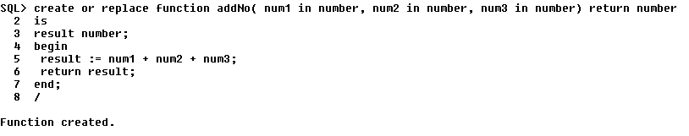

Output:

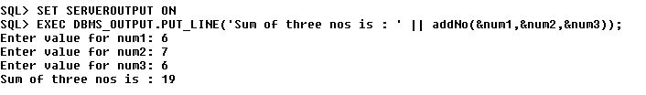

**Create function for average of 3 nos:**  
 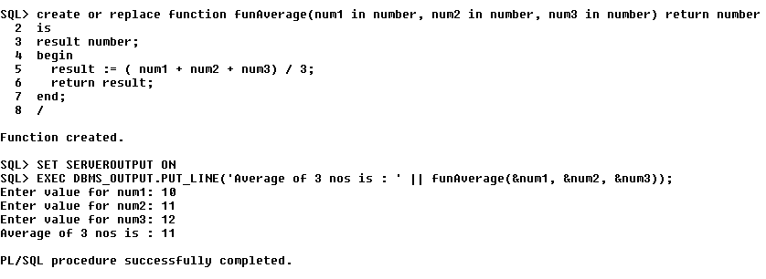

**Create function for factorial:**  
